Chapter 2, Solution 49

Transform the circuits in Fig. 2.113 from Δ to Y.
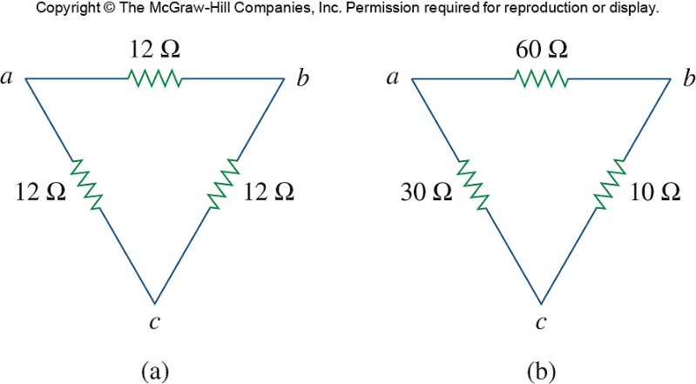

Figure 2.113
For Prob. 2.49.

Solution

(a) R₁ =

R₁ = R₂ = R₃ = 4 Ω

R₁ = 18Ω, R₂ = 6Ω, R₃ = 3Ω

